Grazioso Salvare Application System Architecture Documentation

SNHU CS-340 Client/Server Development - Athena Trunkhill

Project Functionality & Client Application Scope
This web-based client/server dashboard was engineered as a decision-support utility tool for Grazioso Salvare to rapidly analyze shelter rescue outcomes. The system pulls live animal records from the regional network databases and presents them through a clean, streamlined dashboard environment designed to minimize training latency and software input errors. Users can activate targeted filtering toggles to screen for candidates matching rigorous rescue training specifications.

System Architecture & Component Rationale
The dashboard layout applies a strict Model-View-Controller structural design pattern to isolate application logic layers:
• Model Tier (MongoDB): Selected as the core unstructured data layer store to organize shelter documents seamlessly without rigid schema definitions. MongoDB's flexible, document-centric collections map naturally to native Python dictionary elements, speeding up spatial lookups and property updates.
• View Tier (Dash Components & Leaflet Canvas): Provides a responsive visual presentation interface directly inside the client's browser window, handling pagination grids, geometric tracking maps, and dynamic categorical charts seamlessly.
• Controller Tier (Python Callbacks & CRUD Library): Acts as the data routing engine. When a user alters a filter selection, the callback method updates dashboard views dynamically using your robust backend connection class commands (CRUD_Python_Module.py).

Step-by-Step Environment Replication Instructions
To replicate this application deployment on an alternative host network environment, execute the following configuration pipeline:
1. Initialize the background MongoDB server architecture instance and run data ingestion utilities to load the regional shelter data set into the targeted collection.
2. Configure database authentication policies and export an active user profile inside the admin collection matching your script's connection tokens.
3. Deploy your standalone class module library (CRUD_Python_Module.py) directly inside your execution workspace folder.
4. Launch the main configuration cell inside your Jupyter Notebook dashboard file (ProjectTwoDashboard.ipynb) to spin up your responsive proxy server connection link.

Project Roadmap Obstacles & Technical Resolutions
During full-stack system implementation, a port configuration exception emerged when initializing subsequent dashboard instances (OSError: [Errno 98] Address already in use). This architectural collision occurred because an earlier application pipeline process remained active on the network interface, holding the default port block channel securely. This engineering bottleneck was resolved by reconfiguring the application runtime method to bind explicitly to an alternative listening channel (port=8051), thereby completely bypassing the socket binding conflict and restoring fluid communication channels across all layout components.

Functional Testing Executions Verification
1. Water Rescue Filter Applied 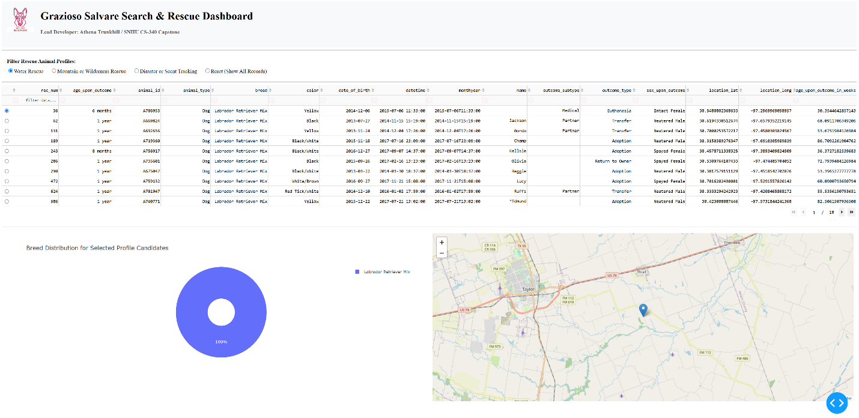

2. Mountain or Wilderness Rescue Filter Applied 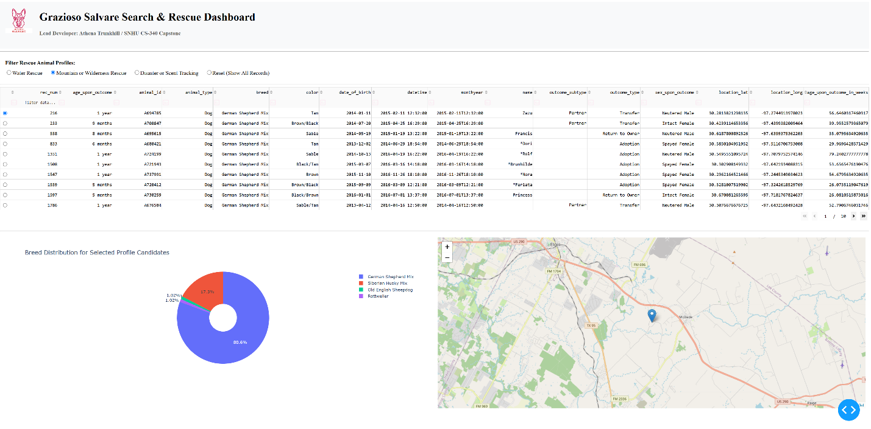

3. Disaster or Scent Tracking Filter Applied 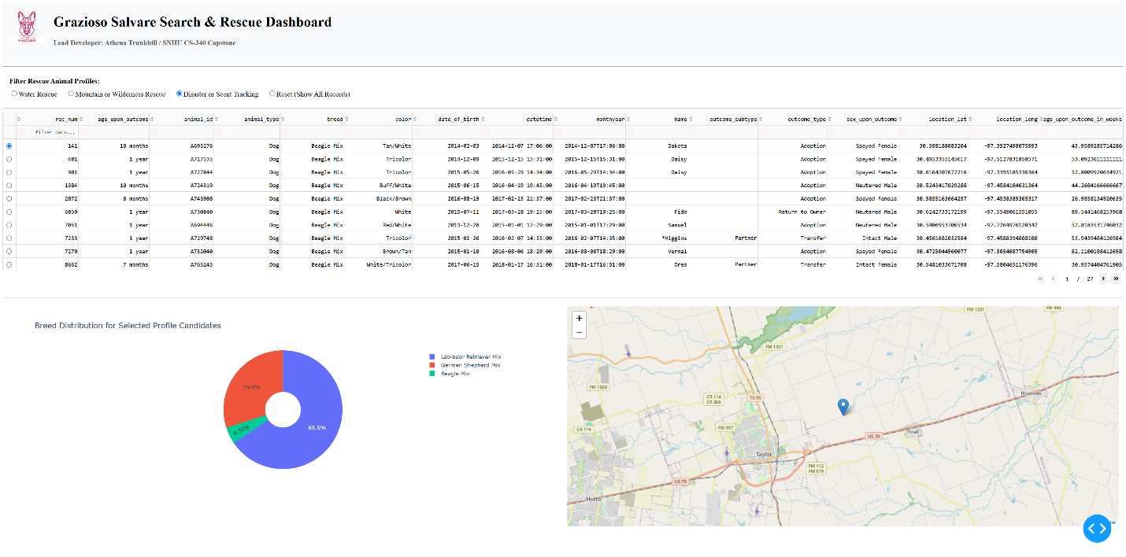

4. Reset Dashboard Filter State 